**EXP-10**

**3D Model Creation and Texturing in Blender**

**Aim:**

To create a simple 3D model (e.g., house or basic object) in Blender and apply basic shading and textures to enhance its appearance.

**Procedure:**

1. Open Blender and start a new project.
2. Use basic mesh primitives (cube, cylinder, plane, etc.) to build the shape of the object.
3. Edit the mesh by moving, scaling, and extruding vertices, edges, and faces to form the desired model.
4. Switch to the **Shading** workspace to work on materials.
5. Create a new material and apply it to the model.
6. Assign base colors using the **Principled BSDF** shader or other shading nodes.
7. Add textures by importing image files and connecting them to the shader nodes (e.g., using an Image Texture node).
8. Adjust shading properties such as roughness, metallic, and specularity to control how the surface interacts with light.
9. Set up simple lighting in the scene to showcase the model’s shading and textures.
10. Use the viewport shading modes or render the scene to visualize the final output.
11. Rotate and view the model from different angles to verify the shading and texture application.

**Output:**

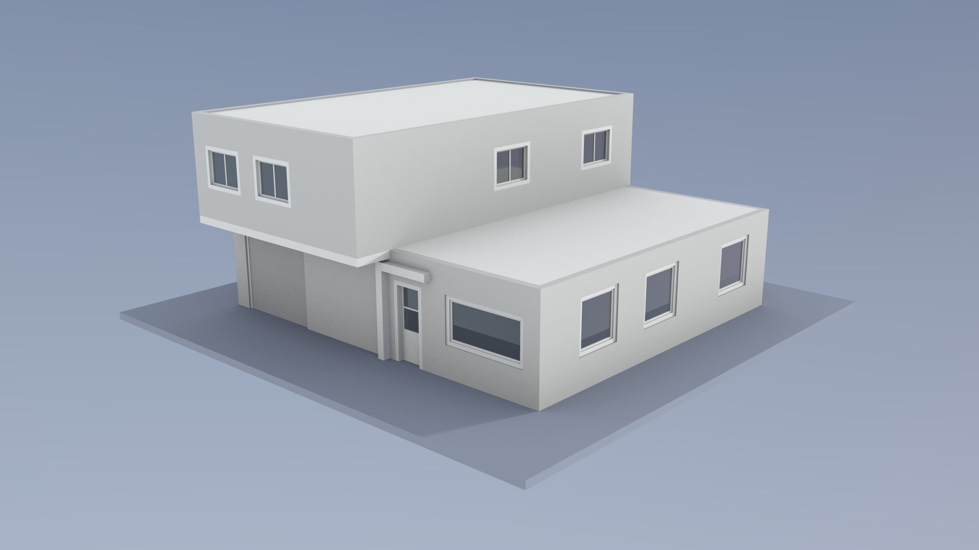

**Result:**

The project successfully created and rendered a simple 3D model—a basic house composed of geometric shapes such as cubes and cones. Textures were applied to the walls and roof, and basic shading techniques were used to enhance realism. The final model was clearly visualized in 3D from multiple angles, showing proper lighting, color, and surface texture.